Miss Manners Test

Abstract 2
Configuration 3
Project Location and Content 3
Deploying and Running 4
Benchmark 4
API 5

Abstract
“Miss Manners” is a performance benchmark for rule engines. The scenario is as follows:
“Miss Manners has invited guests with various hobbies to a dinner party. She wants to seat the guests in male-female-male-female arrangement so that each guest will have someone on the left or right that has a common hobby.”
This example will allow you to do the following in TIBCO BusinessEvents®:
- Run the benchmark.
- Examine and run a sample TIBCO BusinessEvents API program.

Configuration

Project Location and Content
The TIBCO BusinessEvents Studio project that implements the benchmark can be found at:
TIBCO_BE_HOME/examples/standard/MissManners/MissMannersProject
This project contains the following folders:
Deployment: Contains the Enterprise Archive resources:
- MissManners_8Guests: Use this to run the benchmark in the 8-guests configuration.
- MissManners_API: Use this to run the sample API program. See ‘Deployment and Running’ section.
Functions: Contains the rule functions used for computation of seat assignment and for print jobs.
Model: Contains the entity resources with their definition and properties.
Rules: Contains the rules for the seat assignment. These rules are explained briefly as follows:
- AssignFirstSeat: Assigns the first seat to one of the guests.
- AssignSeat: Assigns all the remaining seats to the remaining guests.
- PrintResult: This rule prints the total time taken for the entire process of seat assignment as well as the final seating arrangement.
- Start: Starts the seat assignment process.
- Reset: Resets all the seats assignments.

Deploying and Running

Benchmark
- Open the project ‘MissMannersProject’ using TIBCO BusinessEvents Studio.
- Build an EAR file using the Project->Build Enterprise Archive command.
- Start the TIBCO BusinessEvents engine with MissManners_8Guests.cdd from the Deployment folder of the project.
- Check the test results in the log file:
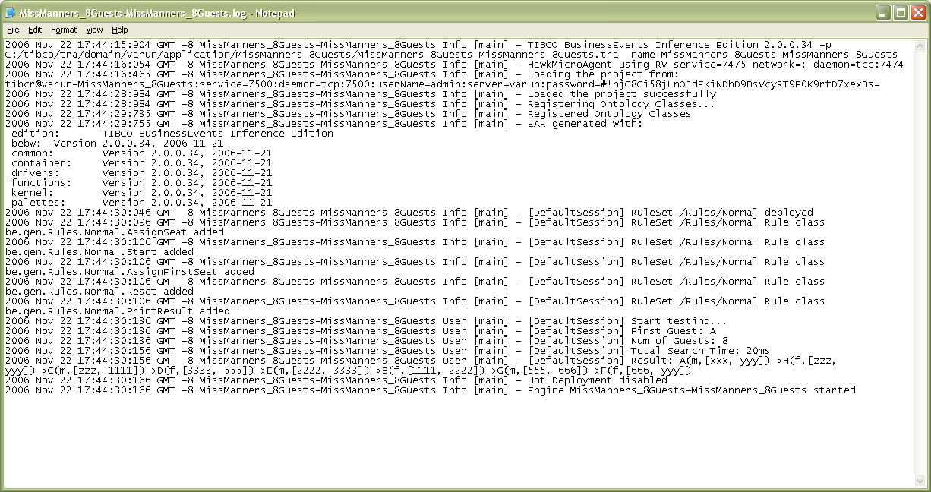

API
- Open the project ‘MissMannersProject’ using TIBCO BusinessEvents Studio.
- Using the Project->Build Enterprise Archive command, create an EAR file named ‘MissManners_API.ear’ in the directory
TIBCO_BE_HOME/examples/standard/MissManners/MissMannersAPI/bin
[Note: You may have to change the value of File Location.]
- Update the various paths, in the following file, to match your environment:
TIBCO_BE_HOME/examples/standard/MissManners/MissMannersAPI/bin/setenv.bat
- Compile the API program by running MissMannersCompile.bat:
TIBCO_BE_HOME/examples/standard/MissManners/MissMannersAPI/bin/MissMannersCompile.bat
- Run the API program by running MissMannersRun.bat:
TIBCO_BE_HOME/examples/standard/MissManners/MissMannersAPI/bin/MissMannersRun.bat
Note: You can change the number of guests used in the test by changing INPUT_DATA_PATH.
For example:
SET INPUT_DATA_PATH=%MISSMANNERS_HOME%\MissMannersAPI\inputData\mann256.dat
- Observe the results in the output of the MissMannersRun.bat command.

